**Functional Design**

**Version 1.2**

**Table of Content**

**1. Preface** 3

**2. Functionalities** 3

**3. Sitemap** 4

**4. Navigation Structure** 5

**5. Design** 5

**6. Wireframe** 5

**7. Use Case** 6

**8. Data Model** 7

**9. Security** 7

**10. Maintenance** 7

**11. Summary** 8

**12. Version Management** 8

**13. Disclaimer** 8

**14. Sources** 8

# **1. Preface**

**1.1 Introduction**

You are working for the application and media development department of an IT company. This company is hired to develop a reservation website for **Hotel California**. The website will replace the full paper administration of the reservation desk.

**1.2 Hotel California**

The company is **Hotel California**. They are a Dutch hotel company that wants to improve their quality and make their customers leave with a big smile. Since they are still using full paper administration for reservations, they wanted to make it faster and easier for both customers and the hotel itself. The hotel keeper has been in the hotel business for 20 years and seen many hotels switch over to an automatic reserving method which has been a success most times.

**1.3 Target Audience**

The website will be primarily used for customers who want to stay at Hotel California for the night. Everyone above 18 years old is allowed to book and reserve a room to stay for the night.

# **2. Functionalities**

**2.1 Must have functionalities**

There are a couple of functionalities that **MUST** function correctly if the reservation website is going live, they are as followed:

1. The hotelkeeper **must** be able to see a room plan with the location of the rooms.
2. The hotelkeeper **must** be able to add the category of rooms available in the system.
3. The hotelkeeper **must** be able to print a list of rooms and the category they belong to.
4. In the room plan, the hotelkeeper **must** be able to assign the category that the room belongs to.
5. The reservation desk **must** be able to assign a room price for one of the 3 categories of rooms for a certain day of the year. The pricing system **must** be filled in, at least 3 months in advance.
6. The reservation desk **must** be able to retrieve a list of room prices per day. They also **must** be able to print this list.
7. Web visitors **must** be able to see the available categories of rooms and prices for those categories from a certain start-to an end date.
8. The web visitor **must** be able to make a reservation.
9. The hotelkeeper **must** be able to see and print a list of occupied and reserved rooms within a certain period.
10. The front desk **must** be able to print a list of room prices for a week.
11. The front desk **must** be able to see all unoccupied and the amount of not reserved (vacant) rooms on a certain day per category.
12. The front desk **must** be able to register a guest as an occupant of a room.
13. The front desk **must** be able to see if the room is prepaid or post-paid.
14. In the case of a post-paid room, the front desk **must** be able to print an invoice for the room rent (free) that is due.

**2.2 Should have functionalities**

Besides having functionalities that are a must some functionalities that **SHOULD** function correctly, this can be for the user experience or something else, they are as followed:

1. The reservation website **should** have a login system. This will be for both customers and administrators.
2. The reservation website **should** have a calendar.
3. The reservation website **should** have an admin panel for the administrators to make changes or view reservations.

**2.3 Could have functionalities**

Here is a list of functionalities that **COULD** be a part of the reservation website, they are as followed:

1. There **could** be an invoicing system for minibar usage during a stay.
2. There **could** be a ticket system for room service (chef and waiter).
3. There **could** be room service tickets that connect to the invoicing system.
4. There **could** be a cleaning alert on the floor map at checkout.
5. There **could** be a cleaning roster with the most efficient route.

**2.4 Won’t have functionalities**

Here is a list of functionalities that **WON’T** be a part of the reservation website, they are as followed:

1. The reservation website **won’t** be available in multiple languages. It will only be available in English.
2. The reservation website **won’t** have a “chat with a staff member” on the website. However, you can read the FAQ.
3. The reservation website **won’t** make use of discount codes.

# **3. Sitemap**

**3.1 What is a sitemap? [1]**

A sitemap is a file where you provide information about the pages, videos, and other files on your site, and the relationships between them. Search engines like Google read this file to more intelligently crawl your site. A sitemap tells Google which pages and files you think are important in your site and provides valuable information about these files: for example, for pages, when the page was last updated, how often the page is changed, and any alternate language versions of a page.

**3.2 The website sitemap**

* Home
  + Company
    - Mission
    - Our Team/Staffs
    - About Us
  + Booking/Reserve a room
    - Category
      * 1 Person
      * 2 Person
      * Family
      * Luxury
  + Contact
    - FAQ
    - Contact Us
  + Login/Register
    - Create Account/ Login as an existing user
    - View Profile
    - My Bookings/Reservation

# **4. Navigation Structure**

­

Home

Company

Contact

Booking

Login/Register

1 Person

Category

2 Person

Profile

Mission

Luxury

Family

About Us

My Bookings

Our Team

# **5. Design**

**5.1 Color scheme**

For this website, I will be using the color scheme of **black** and **white**. It will create a really good looking website.

**5.2 Font**

As for the font, I will be using a couple of google font; **Noto Sans JP [2]**, **Montserrat [3]**, and **Roboto [4]**. They are all great font to use and have a good synergy together for attracting customers to your website.

**5.3 Image**

And lastly, I will be using **pexels** [5] as my source of images. It has some really clean photos to use for this project and the photos are free to use.

# **6. Wireframe**

**6.1 Information**

This is just a **sketch**. The end product will look different.

**6.2 Home**

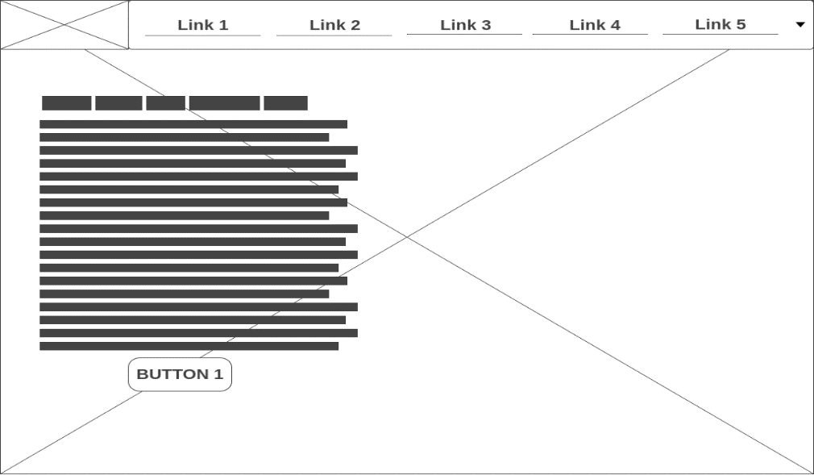

*Image 1: Home/Landing page design.*

**6.3 Reservation**

*Image 2: Reservation page design.[6]*

**6.4 Contact**

*Image 3: Contact page design.[7]*

**6.5 Login/Register**

*Image 4: Login/Register page design.[8]*

# **7. Use Case**

**7.1 What is a use case? [9]**

In software and systems engineering, a use case is a list of actions or event steps typically defining the interactions between a role and a system to achieve a goal.

**7.2 Reservation System**

*Image 5: Use case for the reservation system.*

# **8. Data Model**

**8.1 What is a data model? [10]**

It’s an abstract model that organizes elements of data and standardizes how they relate to one another.

**8.2 The Process**

*Image 6: Data model when booking a room.*

# **9. Security**

**9.1 Access**

The website can be accessed by **anyone**, however to reserve/book a room **MUST** have an existing account, or you can create a new one. The privileges of an existing member or new member are limited, it is **NOT** possible for them to make any changes to the website. However, with an admin account, it is possible to make changes to the websites. There will only be **1** admin account to decrease hacking possibility.

**9.2 Security**

To increase the security on the website each member will be tracked, the admin can see each individual member and what they are doing. When closing / leave the website the tracking will stop. All of the users’ actions will be stored in a **LOG.DAT** file. This also applies to the admin account.

# **10. Maintenance**

**10.1 Maintenance**

I will be maintaining the website after the live release, in case of any bugs or something not functioning I will be fixing them.

**10.2 Device**

As for my laptop is it an ASUS VivoBook S14 with Windows 10 v1909 installed as the OS. For my desktop computer, I am using a late 2014 iMac with macOS Catalina 10.15.4 installed as my OS. On both my devices I have Visual Studio Code installed. I am using the GIT client GitHub to synchronize my work into the same repository.

# **11. Summary**

To summarize it all up, in this document you will find a list of functionalities for the website, these functionalities are ordered by the MoSCoW analysis. They are ranked by **must**, **should**, **could**, and **won’t**. Also, in this document, you will find the sitemap for the website, keep in mind it can be changed. Besides a sitemap, there is also a navigation structure to give you a visual idea of what happens when you click on a certain link. I have also attached multiple images to demonstrate how it will look like or how data will connect to one or another. Also, in those pictures, there are wireframes, I have not made all wireframes for all the pages which will be on the website, but this is a rough sketch on how things will look, and the final product might differ towards a different design. I have also described what color scheme I will be using for the website, the fonts I will use, which are google fonts, and where I will get my images from, which is free to use so there will be no copyright strike when the website goes live. In those pictures there are also some photos related to the reservation system, for example, the use case, it is a rough idea on how it will work when a customer tries to book/reserve a room. And there is also a data model to see how the data which will be saved will be transported from table to table and correctly function. And lastly, there is information about security, maintenance, and the company.

# **12. Version Management**

|  |  |
| --- | --- |
| Version | Date |
| 1.0 | 23 April 2020 |
| 1.1 | 29 April 2020 |
| 1.2 | 30 April 2020 |

# **13. Disclaimer**

**13.1 Privacy**

Personal data is processed by Hotel California in accordance with the Personal Data Protection Act. The information that is provide on the website will be treated confidentially and carefully.

**13.2 Rights**

Hotel California cannot be held responsible for the content of any internet site that is linked to this internet site via a link. All texts and images on this website are owned by Hotel California.

# **14. Sources**

**14.1 Origin**

* Sitemap [1]: <https://support.google.com/webmasters/answer/156184?hl=en>
* Noto Sans JP [2]: <https://fonts.google.com/specimen/Noto+Sans+JP>
* Montseratt [3]: <https://fonts.google.com/specimen/Montserrat>
* Roboto [4]: <https://fonts.google.com/specimen/Roboto>
* Pexels [5]: [https://www.pexels.com](https://www.pexels.com/)
* Reservation [6]: cheatsheet.png from DAVER
* Contact [7]: cheatsheet.png from DAVER
* Login/Register [8]: cheatsheet.png from DAVER
* Use Case [9]: <https://en.wikipedia.org/wiki/Use_case>
* Data Model [10]: <https://en.wikipedia.org/wiki/Data_model>

**14.2 Copyright**

© All Rights Reserved. Document owned by Jun Yi Xie.